**Aim:**

To demonstrate Storage as a Service (SaaS) by creating and configuring cloud storage in a public cloud service provider (Azure).

**Procedure:**

1. Select a Public Cloud SaaS Service

* Examples:
  + Google Drive / Google Workspace
  + Microsoft OneDrive / Office 365
  + Dropbox

2. Sign In and Access the Storage Platform

* Open the SaaS service in a web browser.
* Sign in with your credentials.

3. Upload a File

* Click Upload → File or Upload → Folder
* Select a file from your local machine.

4. Organize Storage

* Create folders, rename files, or share with others.
* Check features like versioning, sharing, and access permissions.

5. Download / Edit Files

* Open or edit files directly in the cloud application.
* Download files to verify data integrity.

**Storage Account Overvie:**

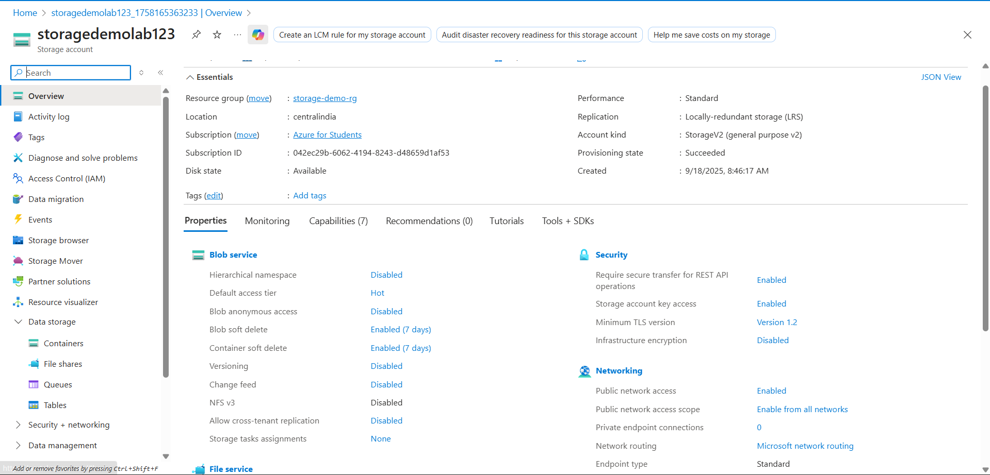

**Container with uploaded blob:**

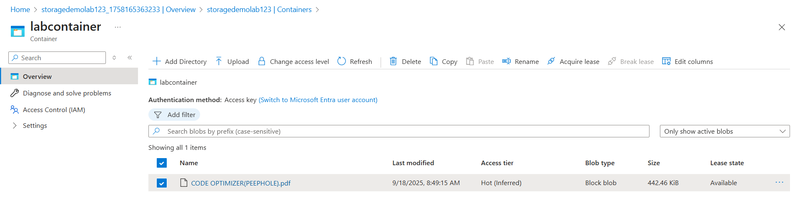

**Uploaded blob:**

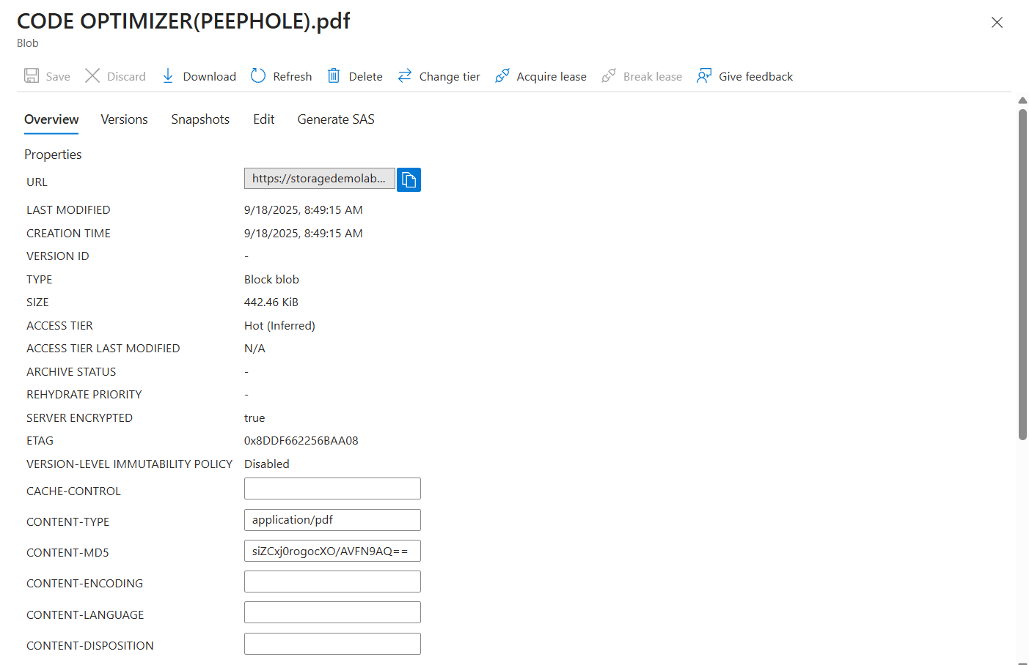

**Result:**

* Files were successfully uploaded, managed, and shared through the cloud-based SaaS storage application.
* No virtual machines or server configuration were needed, demonstrating Software as a Service where the provider manages all backend infrastructure.